NAME: KARTHIGA G SLOT: A
REG NO:192421383 SUB: CLOUD COMPUTING

EXP NO :1 STUDENT MANAGEMENT SYSTEM (SaaS)

AIM
To develop a simple Student Management Application and deploy it as SaaS using Zoho Creator.
ALGORITHM
- Start
- Login to Zoho Creator
- Create a new application
- Create a form for student details
- Add required fields (Name, Roll No, Department, Email)
- Create a report to display data
- Run the application
- Enter sample data
- View data in report
- Share application link
- Stop
PROCEDURE
- Login to Zoho Creator
- Create application (MySaaSApp)
- Create form (StudentForm)
- Add fields: Name, Roll Number, Department, Email
- Create report (StudentReport)
- Run application and enter data
- View data in report
- Copy and share link

OUTPUT SCREENSHOT
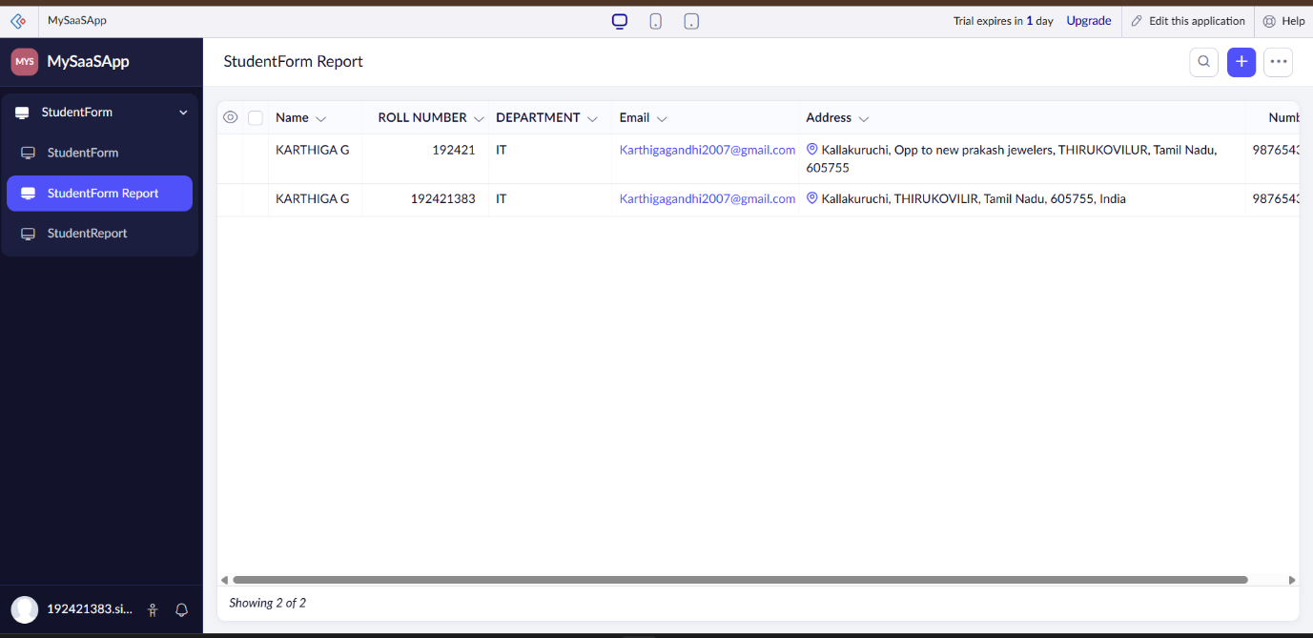

RESULT
A Student Management System was successfully developed and deployed as SaaS using Zoho Creator.

